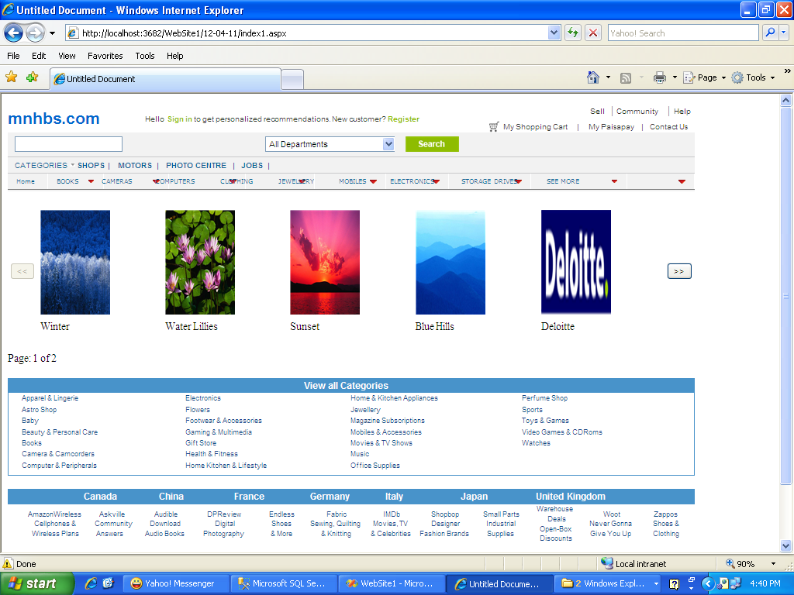

In this mnhbs I had done the work of storing the images in the database and displaying it in the datalist and also done the pagging for the datalist there I had displayed the 5 images in on e page and after every page contains the 5 images in the next page. And finally the images in the mnhbs will be displayed from our database only so that we can deleted, or change the images as per our requirement.